**Date: 28/3/25**

# EXPERIMENT: 23 IMPLEMENTATION OF IOT DEVICES IN NETWORKING

**Aim:** To implement an IOT devices in networking using Cisco Packet Tracer.

**Software/Apparatus required:** Packet Tracer/End devices, Hubs, connectors.

**Procedure:**

**Steps:**

1. Open Cisco Packet Tracer and create a new project.

Drag and drop a router from the "Devices" panel onto the workspace area.

1. Connect the router to the Internet by dragging and dropping a "Cloud" device from the "Devices" panel onto the workspace area, and then connecting the router to the cloud using a straight-through cable.
2. Add an IoT device to the network by dragging and dropping a device from the "Devices" panel onto the workspace area. There are various IoT devices available in the "Devices" panel, such as a Raspberry Pi or an Arduino.
3. Connect the IoT device to the router using an Ethernet cable. To do this, click on the IoT device and then click on the "Config" tab. Under the "Interfaces" section, select the Ethernet interface and then click on the "+" button to add a new interface. Connect the new interface to the router.
4. Configure the IoT device by clicking on it and then clicking on the "CLI" tab. This will bring up the command line interface for the IoT device, where you can configure its settings.
5. Test the connectivity of the IoT device by pinging it from the router or from another device on the network.
6. These are just general steps and the specifics of the implementation will depend on the specific IoT device and network configuration you want to create. Additionally, you may need to configure the router and the cloud device to enable Internet connectivity for the IoT device.

Diagram:

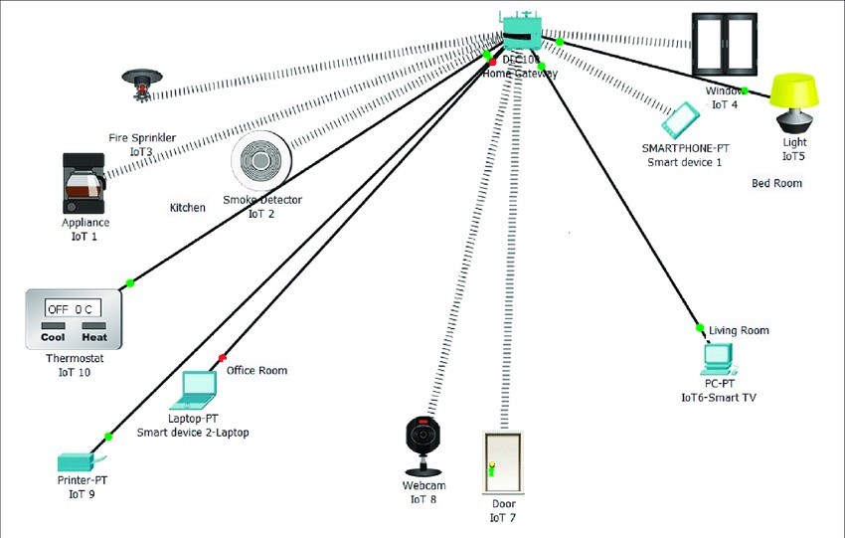

**Result:** Thusan IOT device in networking is implemented using Cisco Packet Tracer successfully.